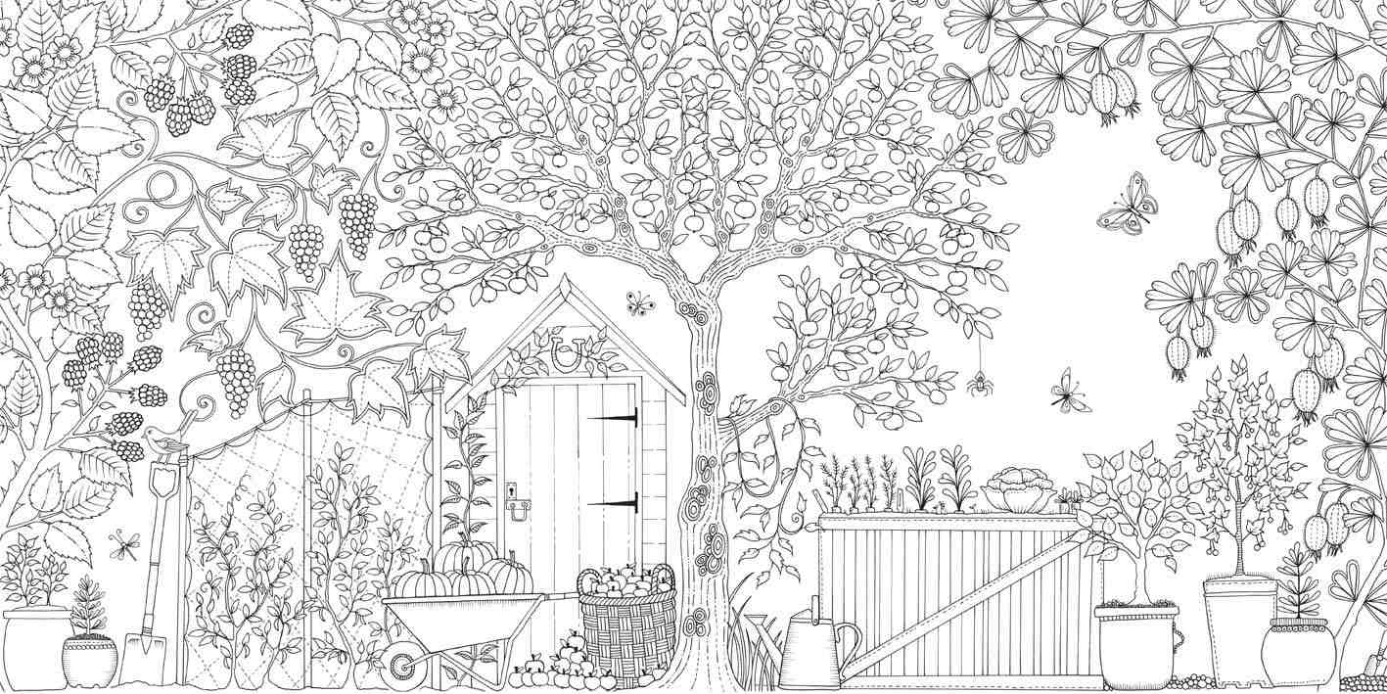
ADULTS 18+
NAME:
AGE:
PHONE#

